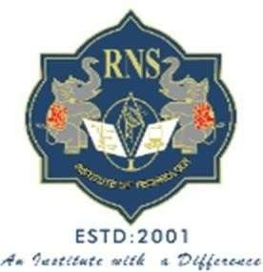

# VISVESVARAYA TECHNOLOGICAL UNIVERSITY

JNANA SANGAMA, BELAGAVI – 590 018

**A project Phase I Report on**

# GESTURE CRAFT SLIDER

Submitted in partial fulfillment of the requirements for the VII Semester of degree of **Bachelor of Engineering in Information Science and Engineering** of Visvesvaraya Technological University, Belagavi

#### Submitted By

**JEEVAN NY 1RN20IS064 KARTHIK P 1RN20IS072**

**MAITHREYA TM 1RN20IS083 S PRAJWAL 1RN20IS128**

#### Under the Guidance of

**Dr. Sunitha K**

**Assistant Professor Department of ISE**

**Department of Information Science and Engineering**

# RNS Institute of Technology

### Dr. Vishnuvaradhan Road, Rajarajeshwari Nagar post, Channasandra, Bengaluru-560098

**2023-2024**



# RNS INSTITUTE OF TECHNOLOGY

### Dr. Vishnuvaradhan Road, Rajarajeshwari Nagar post, Channasandra, Bengaluru - 560098

**DEPARTMENT OF INFORMATION SCIENCE AND ENGINEERING**

# CERTIFICATE

Certified that the project work phase 1 entitled **GESTURE CRAFT SLIDER** has been successfully completed by **JEEVAN NY (1RN20IS064), KARTHIK P (1RN20IS072), MAITHREYA TM (1RN20IS083) and S PRAJWAL (1RN20IS128)** bona fide students of **RNS Institute of Technology, Bengaluru** in partial fulfillment of the requirements for the award of degree in **Bachelor of Engineering in Information Science and Engineering** of **Visvesvaraya Technological University, Belagavi** during academic year **2023-2024**. The project phase 1 report has been approved as it satisfies the academic requirements in respect of project phase 1 work for the said degree.

**Dr. Sunitha K Dr. Suresh L Dr. Ramesh Babu H S**

Project Guide Professor and HoD Principal

Assistant Professor Department of ISE RNSIT Department of ISE RNSIT

**Name of the Examiners**

**External Viva**

**Signature with Date**

**1. _ _ 1. _ _**

**2**. **_ _ 2. _**

**DECLARATION**



We, **JEEVAN NY (1RN20IS064), KARTHIK P (1RN20IS072), MAITHREYA TM (1RN20IS083) and S PRAJWAL (1RN20IS128)**, students of VII Semester BE, in Information Science and Engineering, RNS Institute of Technology hereby declare that the Project work phase 1 entitled ***GESTURE CRAFT SLIDER*** has been carried out by us and submitted in partial fulfillment of the requirements for the *VII Semester degree of* ***Bachelor of Engineering in Information Science and Engineering*** *of Visvesvaraya Technological University, Belgaum* during academic year 2023-2024.

**Place:** Bengaluru

#### Date:

**JEEVAN NY [1RN20IS064]**

**KARTHIK P [1RN20IS072]**

**MAITHREYA T M [1RN20IS083]**

**S PRAJWAL [1RN20IS128]**

# ABSTRACT

Presentations are crucial in many aspects of life. If you're a student, an employee of the company, or if you are an entrepreneur, a businessperson, you must have presented presentations eventually in your life. Sometimes, presentations lose vitality because you must use the keyboard or a specialized gadget to adjust and manage the slides. Our objective is to allow people to control the slideshow using hand gestures. The usage of gestures in human-computer interaction has drastically risen in recent years. The system has tried to govern numerous PowerPoint functionalities using hand movements. In this system, machine learning has been applied to recognize motions with tiny differences and map them using multiple libraries in Python. The rising hurdles to creating the optimal presentation are due to several aspects, including the slides, the keys to changing the slides, and the audience's calmness. An intelligent presentation system employing hand gestures gives a simple method to control the slides. There are several pauses during presentations to operate the presentation using the keyboard. The system's purpose is to enable users to use hand gestures to control and explore the slideshow. The technique employs machine learning using **OpenCV** to identify various hand gestures for many tasks. A recognition technique offers an interface for human system communication.

# ACKNOWLEDGMENT

The fulfillment and rapture that go with the fruitful finishing of any assignment would be inadequate without the specifying the people who made it conceivable, whose steady direction and support delegated the endeavors with success.

We would like to profoundly thank **Management** of **RNS Institute of Technology** for providing such a healthy environment to carry out this project work.

We would like to express our thanks to our Principal **Dr. Ramesh Babu H S** for his support and inspired us towards the attainment of knowledge.

We wish to place on record my words of gratitude to **Dr. Suresh L,** Professor and Head of the Department, Information Science and Engineering, for being the enzyme and master mind behind our project work.

We place our heartfelt thanks to **Dr. Sunitha K,** Assistant Professor, Department of Information Science and Engineering for having guided the project and all the staff members of the department of Information Science and Engineering for helping at all times.

We would also like to thank our project coordinator **Dr. Prakasha S,** Associate Professor and **Dr. Bhagyashree Ambore ,** Assistant Professor, Department of ISE, RNSIT, Bangalore, for their valuable suggestions.

We would like to thank all other teaching and non-teaching staff of Information Science & Engineering, RNSIT, Bangalore, who have directly or indirectly helped us to carry out the project work.

**Place:** Bengaluru

#### Date:

**JEEVAN NY [1RN20IS064]**

**KARTHIK P [1RN20IS072]**

**MAITHREYA T M [1RN20IS083]**

**S PRAJWAL [1RN20IS128]**

**TABLE OF CONTENTS**

#### CERTIFICATE

**DECLERATION I**

ABSTRACT II

ACKNOWLEDGMENT III

TABLE OF CONTENTS IV

LIST OF FIGURES V

ABBREVATIONS VI

1. INTRODUCTION 1
2. LITERATURE SURVEY 3
3. PROBLEM STATMENT 15
4. OBJECTIVES 16
5. METHEDOLOGY 17
6. SYSTEM DESIGN 21
7. REFERENCES 29

|  |  |  |
| --- | --- | --- |
|  | **LIST OF FIGURES** |  |
| **Fig No.** | **Description** | **Page No.** |
| Figure 5.1 | Structural Chart of the proposed system | 17 |
| Figure 5.2 | Hand Landmarks | 20 |
| Figure 5.3 | CNN Model | 20 |
| Figure 6.1 | System Architecture | 22 |
| Figure 6.2 | Speech Recognition | 23 |
| Figure 6.3 | Handwriting Recognition | 24 |
| Figure 6.4 | Use Case Diagram of Proposed System | 25 |

## LIST OF ABBREVIATIONS

|  |  |
| --- | --- |
| AI | Artificial Intelligence |
| UI | User Interface |
| CNN | Convolutional Neural Network |
| ML | Machine Learning |

**CHAPTER 1**

## INTRODUCTION

### 1.1 Overview

Our project "Gesture Craft Slider," a system that empowers presenters to control PowerPoint presentations effortlessly through intuitive hand gestures. This novel approach leverages state-of-the-art machine learning algorithms to recognize a diverse range of hand movements, enabling seamless slide navigation, annotation, and interaction with the audience. Gesture Craft Slider transcends the limitations of conventional clickers and keyboard controls, allowing presenters to move freely, enhance their non-verbal communication, and create a more dynamic and captivating presentation experience. By seamlessly integrating with PowerPoint software and employing robust algorithms, this system offers a user-friendly and adaptable solution for academics, professionals, and educators, revolutionizing the way we interact with presentations and fostering a more immersive and impactful communication style. The current system employs a gesture-based interface however, its functionality and user compatibility are restricted and solely relies on gestures for interactions.

Limitations of existing system:

* Can’t able to predict the action if two hands in frame.
* Difficult if hand is too distant.
* Accuracy was not up to the mark.
* Does not have dynamic gesture vocabulary.
* No virtual mouse and keyboard.

**Proposed System:** Gesture Craft Slider proposes a hand gesture-controlled interface for PowerPoint presentations. The system uses machine learning to recognize hand movements and map them to specific presentation functionalities, like slide transitions, pausing, and annotations. This eliminates the need for traditional controls like keyboards, remotes, or mouse clicking, enabling a more natural and dynamic presentation experience.

**CHAPTER 2**

## LITERATURE SUVERY

A literature survey or a literature review in a project report shows the various analyses and research made in the field of interest and the results already published, taking into account the various parameters of the project and the extent of the project. Literature survey is mainly carried out in order to analyze the background of the current project which helps to find out flaws in the existing system & guides on which unsolved problems we can work out. So, the following topics not only illustrate the background of the project but also uncover the problems and flaws which motivated to propose solutions and work on this project.

A literature survey is a text of a scholarly paper, which includes the current knowledge including substantive findings, as well as theoretical and methodological contributions to a particular topic. Literature reviews use secondary sources, and do not report new or original experimental work. Most often associated with academic-oriented literature, such as a thesis, dissertation or a peer-reviewed journal article, a literature review usually precedes the methodology and results sectional though this is not always the case. Literature reviews are also common in are search proposal or prospectus (the document that is approved before a student formally begins a dissertation or thesis). Its main goals are to situate the current study within the body of literature and to provide context for the particular reader. Literature reviews are a basis for researching nearly every academic field. A literature survey includes:

Existing theories about the topic which are accepted universally.

* Books written on the topic, both generic and specific.
* Research done in the field usually in the order of oldest to latest.
* Challenges being faced and on-going work, if available.

Literature survey describes about the existing work on the given project. It deals with problem associated with the existing system and also gives user a clear knowledge on how to deal with the existing problems and how to provide solution to the existing problems so that we can tackle the problem, resolve them in better way by implementing advanced techniques.

### Objectives of Literature Survey

* + Learning the definitions of the concepts.
  + Access to latest approaches, methods and theories.
  + Discovering research topics based on the existing research
  + Concentrate on your own field of expertise– Even if another field uses the same words, they usually mean completely.
  + It improves the quality of the literature survey to exclude sidetracks– remember to explicate what is excluded.

Before building our application, the following system is taken into consideration:

#### Title: Impact Of Human-Computer Interaction (HCI) on Users in Higher Educational System: Southampton University As A Case Study

#### Authors: D. O. Lawrence, M. J. Ashleigh

#### Year: 2019

**Abstract** : Hand gesture recognition system received great attention in the recent few years because of its manifoldness applications and the ability to interact with machine efficiently through human computer interaction. In this paper a survey of recent hand gesture recognition systems is presented. Key issues of hand gesture recognition system are presented with challenges of gesture system. Review methods of recent postures and gestures recognition system presented as well. Summary of research results of hand gesture methods, databases, and comparison between main gesture recognition phases are also given. Advantages and drawbacks of the discussed systems are explained finally. Abstract: This study investigates the impact of Human-Computer Interaction (HCI) on users within the higher education system, using Southampton University as a case study. The authors analyze how HCI principles are applied in learning platforms, online resources, and classroom technology, and evaluate their effectiveness in enhancing student engagement, learning outcomes, and accessibility. They highlight the importance of user-centered design and usability testing in creating efficient and effective educational experiences through HCI.

#### Title: Machine Learning in Python: Main Developments and Technology Trends in Data Science, Machine Learning, and Artificial Intelligence

#### Authors: S. Raschka, J. Patterson, C. Nolet

#### Year: 2020

**Abstract:** This book covers the main developments and technology trends in data science, machine learning, and artificial intelligence. It focuses on Python as the primary programming language for implementing various machine learning algorithms. The book discusses supervised and unsupervised learning, ensemble methods, deep learning, and natural language processing, among other topics. It serves as a comprehensive resource for readers interested in understanding and applying machine learning techniques.

#### Title: A Review of Artificial Intelligence (AI) in Education from 2010 to 2020 Environment

#### Author: X. Zhai, X. Chu, C. S. Chai, M. S. Y. Jong, A. Istenic, M. Spector, J.-B. Liu, J. Yuan, Y. Li

**Year: 2021**

**Abstract:** This paper reviews the applications of Artificial Intelligence (AI) in education from 2010 to 2020. It analyzes various AI-powered systems used for personalized learning, intelligent tutoring, adaptive learning platforms, assessment and feedback, and educational analytics. The authors discuss the potential benefits and challenges of AI in education, highlighting the need for ethical considerations, teacher integration, and continuous research and development.

#### Title : Hand Gesture recognition System to Control Slide Show Navigation

#### Author : D. Jadhav, L. M. R. J. Lobo

#### Year : 2014

**Abstract:** This study presents a hand gesture recognition system for controlling slide show presentations. The system allows users to control slide show presentations using pre-defined hand movements, utilizing a webcam to capture hand gestures and applying image processing techniques to identify features and classify them into specific gestures.

#### Title : Robust part-based Hand Gesture recognition using Kinect sensor

#### Author : Zhou Ren et al

#### Year : 2013

**Abstract :** This research introduces a robust hand gesture recognition system based on the Microsoft Kinect sensor. The system segments the hand region from the background and divides it into multiple parts for feature extraction. These features are then analyzed using a Support Vector Machine (SVM) classifier to identify specific gestures, demonstrating high accuracy and robustness under varying lighting conditions and background noise.

#### Title : Finger-Pointing Gesture Analysis for Slide Presentation

**Author : M. Harika et al.**

**Year : 2016**

**Abstract:** This paper explores the use of finger-pointing gestures for controlling slide presentations. The authors propose a system that detects and tracks the user's fingertip in real-time using computer vision techniques. The direction and movement of the fingertip are then interpreted as navigation commands, offering a natural and intuitive way to interact with slides.

#### Title: An Efficient Approach to Recognize Hand Gestures Using Machine Learning

#### Author : M. F. Wahid, R. Tafreshi, M. Al-Sowaidi, R. Langari

**Year : 2020**

**Abstract:** This study presents an efficient approach for hand gesture recognition using machine learning. The proposed method employs a two-stage classification process, including a skin color detection algorithm and a Support Vector Machine (SVM) classifier, aiming for high accuracy and computational efficiency in real-time applications.

#### Title: Detection of Real-Time Objects Using TensorFlow and OpenCV

#### Author : A. Talele, A. Patil, B. Barse

**Year : 2019**

**Abstract:** This paper focuses on object detection in real-time using TensorFlow and OpenCV. The authors implement a Convolutional Neural Network (CNN) trained on a labeled dataset of images containing various objects, integrated with OpenCV libraries for real-time object detection in live video streams.

#### Title : A New Hand Gestures Recognition System

#### Author : A. K. H. Al Saedi, A. H. H. Al Asadi

**Year : 2020**

**Abstract :** This research proposes a novel hand gesture recognition system combining image processing techniques and machine learning algorithms. The system enhances contrast, applies noise reduction filters, and extracts features like shape, contour, and orientation, which are fed into a Random Forest classifier for gesture recognition.

#### Title: Automated Hand Gesture recognition using a Deep Convolutional Neural Network

#### Author : I. Dhall, S. Vashisth, G. Aggarwal

**Year : 2020**

**Abstract :** This paper explores the use of Deep Convolutional Neural Networks (CNNs) for automated hand gesture recognition. The authors propose a CNN architecture specifically designed for recognizing hand gestures from captured images or video frames, offering greater robustness and adaptability compared to traditional methods.

#### Title: Navigation of PowerPoint using Hand Gestures

**Author : D. R. Jadhav, L. M. Lobo**

**Year : 2018**

**Abstract :** This study presents a hand gesture recognition system for controlling PowerPoint presentations. The system utilizes image processing techniques to identify fingertip locations and hand movements captured through a webcam, mapping specific gestures to PowerPoint navigation commands.

#### Title: Hand Recognition System Using Camera

#### Author : V. Shinde et al.

**Year : 2020**

**Abstract**: This paper investigates hand recognition using a simple camera setup. The authors propose a system that captures hand images and applies image processing algorithms to extract features like size, shape, and orientation, using a machine learning classifier to identify specific hand gestures.

#### Title : Smart Presentation Using Gesture Recognition and OpenCV

**Author : M. Paulson, N. Shilpa Davis**

#### Year : 2019

**Abstract**: This research builds a smart presentation system utilizing hand gesture recognition and OpenCV libraries. The system employs a webcam to capture hand movements, applies OpenCV algorithms for feature extraction and gesture classification, and maps specific gestures to presentation control commands.

#### Title: Remote Guiding Presentations Using Hand Gestures

#### Author : K. Robert, D. Zhu, T. Gedeon

**Year : 2019**

**Abstract**: This paper focuses on using hand gestures for remotely controlling presentations. The authors propose a system where a presenter's hand gestures are captured by a camera and transmitted to a remote device controlling the presentation, offering flexibility and freedom of movement.

#### Title: Real-Time Hand Recognition System for Dynamic Applications

#### Author : S. S. Rautaray, A. Agarwal

#### Year : 2016

**Abstract**: This research introduces a real-time hand recognition system for dynamic applications. The system employs a webcam to capture hand gestures, utilizing image processing techniques for feature extraction and gesture classification, demonstrating potential for use in human-computer interaction, gaming, and virtual reality applications.

#### Title: A Smart System Using Hand Gestures and Speech Recognition

#### Author : Girish et al.

**Year : 2022**

**Abstract**: This paper proposes a smart system that combines hand gesture recognition and speech recognition for enhanced interaction. The system captures hand movements and spoken commands, processing and mapping them to specific actions or controls, aiming to improve accessibility and user experience.

#### Title: Human-Computer Multimodal Interface

#### Author : J. H. Mosquera, De-Lacruise, Loaiza Correa

**Year : 2019**

**Abstract**: This research explores the use of multimodal interfaces combining visual and auditory modalities for human-computer interaction. The authors discuss various approaches for integrating hand gestures, speech recognition, and other modalities to create natural and intuitive interfaces.

#### Title: Smart Presentation Control Using Hand Gestures

**Author : H. Khanum, P. H.B**

**Year : 2022**

**Abstract**: This paper proposes a smart presentation control system using hand gesture recognition. The system captures hand movements through a web camera, applies image processing and machine learning techniques to identify specific gestures, and maps them to presentation control commands, enhancing engagement and accessibility.

#### Title : Gesture-Based PowerPoint System

**Author : M. Rajvat, S. Kular, D. Tyagi**

**Year : 2018**

**Abstract**: This research presents a hand gesture-based PowerPoint control system. The system captures hand movements through a web camera, applies image processing techniques for feature extraction, and employs a machine learning

classifier to identify specific gestures, offering a contactless and interactive way to control presentations.

#### Title : Augmented Reality for Information Kiosk

#### Author : A. B. Waghmare et al.

**Year : 2014**

**Abstract**: This paper explores the application of Augmented Reality (AR) technology in the development of interactive information kiosks. The authors propose an AR-based kiosk system that overlays digital information onto the real-world environment using computer vision and graphics techniques. Users can interact with the displayed information through gestures, touchscreens, or other input devices, accessing details about nearby points of interest, historical landmarks, or product descriptions in a visually engaging and immersive way. The paper discusses the design considerations, technical implementation, and potential benefits of AR kiosks, highlighting their ability to enhance user engagement, accessibility, and information delivery compared to traditional static kiosks. The proposed system demonstrates the potential of AR for creating interactive and informative public spaces, museums, and retail environments.

**CHAPTER 3**

## PROBLEM STATEMENT

By literature survey we got to know that traditional presentation methods often rely on clunky tools like keyboards and remote controls, hindering the speaker's natural flow and engagement with the audience. This disconnect creates static and less captivating presentations, limiting the potential impact they could have.

This project aims to address this challenge by developing a novel user interface that leverages the intuitive power of hand gestures to control PowerPoint presentations. By removing the reliance on external devices and focusing on natural human interactions, we hope to achieve the following:

* Enhanced engagement: Gesture control allows presenters to move freely and connect with their audience on a deeper level, fostering a more dynamic and interactive presentation experience.
* Simplified control: Intuitive hand gestures provide a quick and easy way to navigate slides, highlight key points, and add annotations, eliminating the need for clunky tools and minimizing distractions.
* Immersive storytelling: The seamless integration of hand gestures with the presentation content allows for a more natural and expressive delivery, enabling presenters to weave their narratives in a way that resonates with the audience.
* Accessibility: Gesture control removes physical barriers and fosters inclusivity, making presentations accessible to individuals with limited mobility or who find traditional interfaces challenging.

By overcoming the limitations of current presentation methods, this project holds the potential to revolutionize the way we deliver information and connect with audiences. It aims to create a more engaging, dynamic, and accessible presentation experience that empowers speakers to tell their stories in a way that truly resonates.

**CHAPTER 4**

## OBJECTIVES

* To control PowerPoint presentations, fostering a more dynamic and engaging experience for both presenters and audiences.
* To move freely and connect with the audience on a deeper level using intuitive hand gestures.
* To navigate slides, highlight key points, and add annotations through hand gestures, minimizing distractions and maximizing focus.
* To offer an inclusive presentation experience for individuals with limited mobility or who find traditional interfaces challenging by leveraging gesture control.
* To integrate hand gestures seamlessly with presentation content, allowing presenters to weave their narratives in a natural and expressive way.
* To ensure seamless integration with existing PowerPoint software, catering to the needs of various presenters and maximizing adaptability.
* To provide presenters with a nuanced and non-verbal channel to convey emotions, emphasize points, and connect more intimately with their audience through hand gestures.
* These objectives prioritize improving the presentation experience for both the presenter and the audience by leveraging the intuitive power of gesture recognition. They emphasize natural interaction, accessibility, and storytelling capabilities, marking a transformative leap in the realm of presentation control.

**CHAPTER 5**

## METHODOLOGY

**SYSTEM IMPLEMENTATION**

### Structural Design

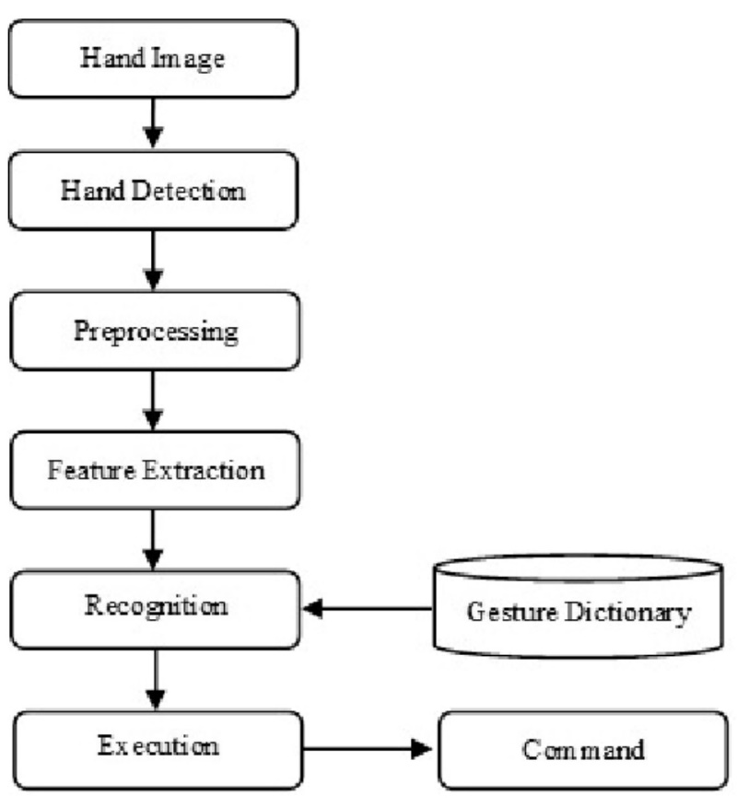

**Figure 5.1:** Structural Chart of the proposed system

The figure 5.1 shows the model meticulously analyzes hand gestures and actions through a series of interconnected steps. It begins by extracting a representative frame from the input stream, then transforms it to optimize feature extraction based on the chosen color space model. Next, it employs specialized detection techniques to pinpoint key hand landmarks or key points, acting as essential reference points for interpreting gestures. To isolate these landmarks, the image is converted to a binary representation, highlighting them against the background. Preprocessing techniques then refine the data, mitigating noise and enhancing image quality while preserving the integrity of hand landmark information. Following this, the model extracts a comprehensive set of features, including not only general image characteristics but also the precise coordinates of hand landmarks. This meticulous localization plays a crucial role in the subsequent decision-making process. The core of the model lies in the recognition phase, where extracted features, particularly hand landmarks, are evaluated against predefined criteria or models. This evaluation deciphers patterns and meanings within the features, enabling the model to discern and interpret specific hand gestures or actions. Finally, upon successful recognition, the model executes a designated command or output based on the recognized patterns or features, translating visual information into actionable outcomes. This intricate workflow demonstrates the model's ability to effectively interpret hand gestures and translate them into meaningful outputs, showcasing the potential of computer vision in diverse applications.

### MediaPipe

The ability to perceive the shape and motion of hands can be a vital component in improving the user experience across a variety of technological domains and platforms. For example, it can form the basis for sign language understanding and hand gesture control, and can also enable the overlay of digital content and information on top of the physical world in augmented reality. While coming naturally to people, robust real-time hand perception is a decidedly challenging computer vision task, as hands often occlude themselves or each other (e.g. finger/palm occlusions and handshakes) and lack high contrast patterns.

MediaPipe Hands is a high-fidelity hand and finger tracking solution. It employs machine learning (ML) to infer 21 3D landmarks of a hand from just a single frame. Whereas current state-of-the-art approaches rely primarily on powerful desktop environments for inference, this method achieves real-time performance on a mobile phone, and even scales to multiple hands. This project provides the hand perception functionality to the wider research and development community will result in an emergence of creative use cases, stimulating new applications and new research avenues.

### Palm Detection Model

To detect initial hand locations, we designed a single-shot detector model optimized for mobile real-time uses in a manner similar to the face detection model in MediaPipe Face Mesh. Detecting hands is a decidedly complex task: our lite model and full model have to work across a variety of hand sizes with a large scale span (~20x) relative to the image frame and be able to detect occluded and self-occluded hands. Whereas faces have high contrast patterns, e.g., in the eye and mouth region, the lack of such features in hands makes it comparatively difficult to detect them reliably from their visual features alone. Instead, providing additional context, like arm, body, or person features, aids accurate hand localization.

This method addresses the above challenges using different strategies. First, we train a palm detector instead of a hand detector, since estimating bounding boxes of rigid objects like palms and fists is significantly simpler than detecting hands with articulated fingers. In addition, as palms are smaller objects, the non-maximum suppression algorithm works well even for two-hand self-occlusion cases, like handshakes. Moreover, palms can be modelled using square bounding boxes (anchors in ML terminology) ignoring other aspect ratios, and therefore reducing the number of anchors by a factor of 3-5. Second, an encoder-decoder feature extractor is used for bigger scene context awareness even for small objects (similar to the RetinaNet approach). Lastly, we minimize the focal loss during training to support a large number of anchors resulting from the high scale variance. With the above techniques, we achieve an average precision of 95.7% in palm detection. Using a regular cross entropy loss and no decoder gives a baseline of just 86.22%.

### Hand Landmark Model

After the palm detection over the whole image our subsequent hand landmark model performs precise key point localization of 21 3D hand-knuckle coordinates inside the detected hand regions via regression, that is direct coordinate prediction. The model learns a consistent internal hand pose representation and is robust even to partially visible hands and self-occlusions. To obtain ground truth data, we have manually annotated ~30K real-world images with 21 3D coordinates, as shown below (we take Z-value from image depth map, if it exists per corresponding coordinate). To better cover the possible hand poses and provide additional supervision on the nature of hand geometry, we also render a high-quality synthetic hand model over various backgrounds and map it to the corresponding 3D coordinates in order to map the points visually and virtually on hand so that we can track the movement of hands. As discussed the 3D coordinators of hands is shown in Figure 5.2.

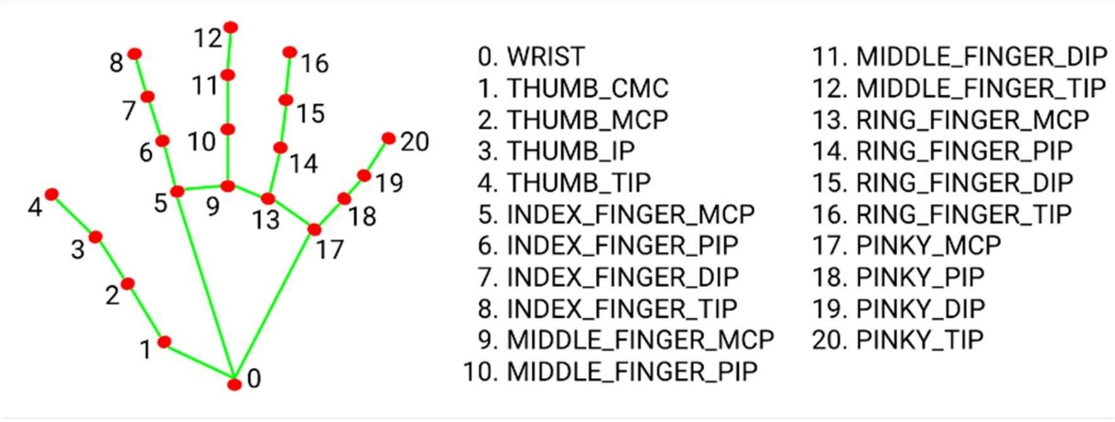

**Figure 5.2:** Hand Landmarks

### CNN for Hand Recognition

Despite having plenty of resources of writing technologies many people from every profession depend on taking notes in a form of paper and pen. And it becomes difficult to maintain and access the notes in a systematic manner. If we have any technology that would convert the handwritten notes in digital format. Then the efficiency of storing handwritten notes will get increased. In this project, the technology will convert every handwritten character in a digital form, it will be helpful to store the data in the long run. This process involves two main approaches first, it processes the image to classify the handwritten characters and captions the handwritten characters. Second, it uses the Convolution Neural network to train the model that will process every pixel of the captioned image and train the neural network i.e. Learning algorithm to predict the handwritten character and thus into digital form as in Figure 5.3.

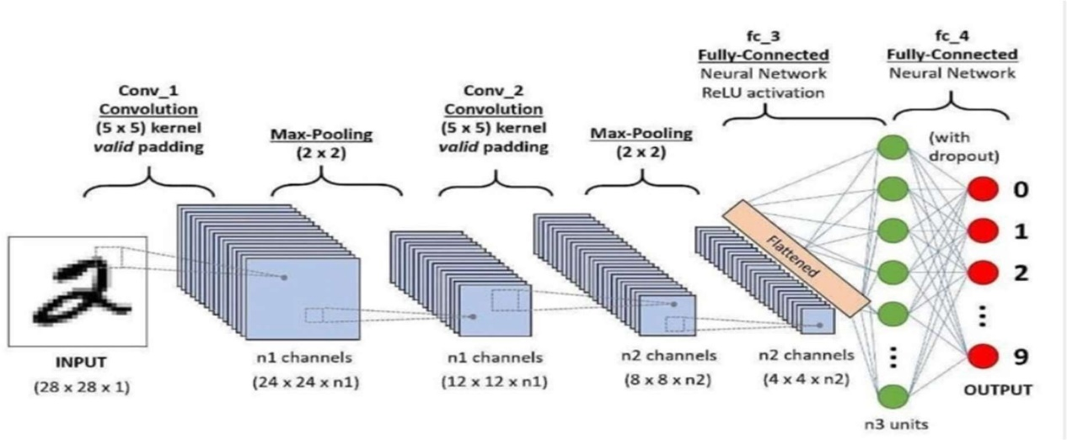

**Figure 5.3:** CNN model

## CHAPTER 6

AI Based UI

**SYSTEM DESIGN**

### Design Overview

The “system design” is defined as the process of applying various requirements and permits it physical realization. Various design features are followed to develop the system the design specification describes the features of the system, the opponent or elements of the system and their appearance to the end-users. The design should be user friendly so that the users can understand and use them effectively.

### System requirements

System requirement specifications gathered by extracting the appropriate information to implement the system. It is the elaborative conditions which the system need to attain. Moreover, the System Requirement and Specifications delivers a complete knowledge of the system to understand what this project is going to achieve without any constraints on how to achieve this goal. This System Requirement and Specification not providing the information to outside characters but it hides the plan and gives little implementation details.

### Hardware Requirement

* Processor: Intel i5
* Processor Speed: 2.4GHz
* RAM: 4GB
* Web Camera

### Software Requirements

* Operating system: Windows 7 or above
* Framework: Anaconda
* Software: Jupyter Notebook or PyCharm IDE or VSCode
* Deep Learning Modules: Tensorflow, Keras
* Computer Vision Module: OpenCv

### System Architecture:

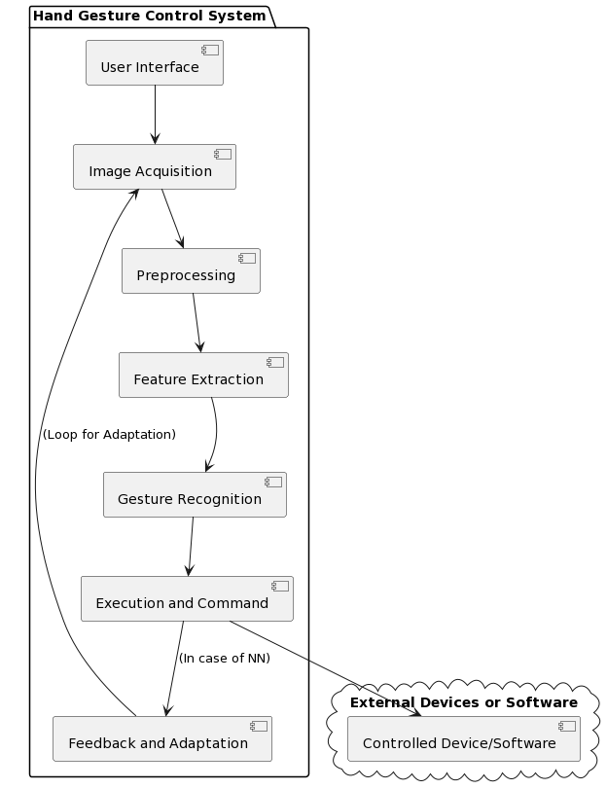

**Figure 6.1:** System architecture

In this above Figure 6.1 shows the overall work flow of the project. The system architecture illustrated in the provided diagram outlines the key components and their interactions. This system is designed for the purpose of controlling PowerPoint, with a specific focus on managing presentations through hand gestures.

1. **User Interface:**

Serves as the interface through which users initiate and interact with the hand gesture control system. Users input commands or gestures to control the presentation.

1. **Image Acquisition:**

Captures images of the user's hand using a camera or sensor, serving as the initial step in the gesture recognition process.

1. **Preprocessing:**

Enhances the quality of captured hand images by reducing noise, normalizing lighting conditions, and segmenting the hand from the background.

1. **Feature Extraction:**

Identifies and extracts essential features from preprocessed images, such as hand shape descriptors, motion dynamics, or texture analysis, to represent hand posture and gestures.

1. **Gesture Recognition:**

Utilizes machine learning algorithms, potentially classifiers or neural networks trained on hand gesture datasets, to recognize specific gestures based on the extracted features.

1. **Execution and Command:**

Maps the recognized gestures to predefined actions or commands, allowing the system to control the presentation. This step involves executing commands such as advancing to the next slide or triggering specific functions.

1. **Feedback and Adaptation:**

Incorporates a feedback mechanism for continuous learning and improvement. In the case of neural networks, this may involve online learning or model adjustments over time based on user interactions. The loop for adaptation indicates an ongoing process to enhance gesture recognition performance.

1. **Controlled Device/Software:**

Represents external devices or software, such as the presentation software being controlled. The "Execution and Command" component communicates with this entity to carry out the recognized gestures, facilitating the effective control of the presentation.

This system architecture provides a systematic framework for developing a hand gesture control system tailored for presentation control, offering users an intuitive and interactive way to navigate and manage presentations through hand gestures.

### Specifications using use case diagrams

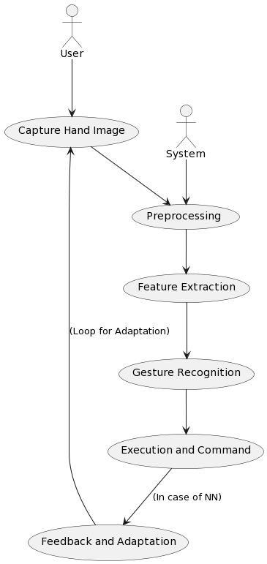

**Figure 6.4:** Use Case Diagram of Proposed System

This hand gesture recognition system operates in a well-defined loop. The user first performs the gesture, which is captured by a camera. The system then preprocesses the image to enhance its quality and extract key features like hand shape, orientation, and finger positions. These features are fed into a machine learning or pattern recognition algorithm that identifies the specific gesture. Based on the recognized gesture, the system triggers an appropriate action or sends a command to another device. For neural network-based systems, there's a unique feedback loop. If the recognition is inaccurate, the system captures additional images and uses them to improve the model's performance, potentially leading to better recognition over time. This concise and adaptable process demonstrates the power of hand gesture recognition technology.

**CHAPTER 7**

## CONCLUSION

The Gesture Craft Slider project is poised to revolutionize the presentation landscape by continuously developing a novel user interface that seamlessly blends gesture recognition with PowerPoint presentations. This innovative system will be empowering presenters to control their slides with intuitive hand movements, fostering a more dynamic, engaging, and immersive presentation experience for both speakers and audiences alike.

At the heart of this ongoing project lies a robust and evolving gesture recognition system that will be continuously learning to accurately identify and interpret a variety of hand gestures, each mapped to specific PowerPoint actions. This will eliminate the reliance on traditional input devices, enabling presenters to move freely and interact more naturally with their content. The interface itself will be continuously optimized for user-friendliness, ensuring a seamless learning curve for those adopting this new method of presentation control.

Through the continued development of this project, we will be demonstrating the vast potential of gesture-based technologies to transform the way we deliver presentations. The Gesture Craft Slider will stand as a testament to the evolving power of human-computer interaction, paving the way for a future of presentations that are not only intuitive and expressive but also captivating for audiences and elevating the art of storytelling to new heights.

**CHAPTER 8**

## REFERENCES

[1] D. O. Lawrence and M. J. Ashleigh, "Impact Of Human-Computer Interaction (HCI) on Users in Higher Educational System: Southampton University As A Case Study", Procedia Computer Science, vol. 54, no. 3, pp. 1-12, Sep. 2019.

[2] S. Raschka, J. Patterson, and C. Nolet, "Machine Learning in Python: Main Developments and Technology Trends in Data Science, Machine Learning, and Artificial Intelligence", 2020.

[3] X. Zhai, X. Chu, C. S. Chai, M. S. Y. Jong, A. Istenic, M. Spector, J.-B. Liu, J. Yuan, and Y. Li, "A Review of Artificial Intelligence (AI) in Education from 2010 to 2020", 2021.

[4] D. Jadhav and L. M. R. J. Lobo, "Hand Gesture recognition System to Control Slide Show Navigation", IJAIEM, vol. 3, no. 4, 2014.

[5] R. Ren et al., "Robust part-based hand Gesture recognition using Kinect sensor", IEEE Transactions on Multimedia, vol. 15, no. 5, pp. 1110-1120, 2013.

[6] M. Harika et al., "Finger-Pointing Gesture Analysis for Slide Presentation", Journal of Korea Multimedia Society, vol. 19, no. 8, Aug. 2016.

[7] M. F. Wahid, R. Tafreshi, M. Al-Sowaidi, and R. Langari, "An Efficient Approach to Recognize Hand Gestures Using Machine", 2020.

[8] A. Talele, A. Patil, B. Barse, "Detection of Real Time Objects Using TensorFlow and OpenCV", Asian Journal of Convergence in Technology, vol. 5, 2019.

[9] A. K. H. AlSaedi, A. H. H. Al Asadi, "A New Hand Gestures Recognition System", Indonesian Journal of Electrical Engineering and Computer Science, vol. 18, 2020.

[10] I. Dhall, S. Vashisth, G. Aggarwal, "Automated Hand Gesture recognition using a Deep Convolutional Neural Network", in 10th International Conference on Cloud Computing, Data Science & Engineering (Confluence), 2020.

[11] D. R. Jadhav, L. M. Lobo, "Navigation of Power point using hand gestures", Walchand Institute of Technology, Solapur IJSR, 2018.

[12] V. Shinde et al., "Hand recognition system using camera", Navsahyadri Education Society, IJERT, 2020.

[13] M. Paulson, N. Shilpa Davis, "Smart presentation using Gesture recognition and OpenCV", Asian Journal of Convergence in Technology, vol. 5, 2019.

[14] K. Robert, D. Zhu, T. Gedeon, "Remote Guiding presentations using hand gestures", APGV, 2019.

[15] S. S. Rautaray, A. Agarwal, "Real-time hand recognition system for dynamic applications", Indian Institute of Technology, Allahabad IJU, 2016.

[16] Girish et al., "A smart system using hand gestures and speech recognition", IJARSCT, 2022.

[17] J. H. Mosquera, De-Lacruise, Loaiza Correa, "Human-computer multimodal interface", IJRTI, 2019.

[18] H. Khanum, P. H.B, "Smart presentation control using hand gestures", IRJET, 2022.

[19] M. Rajvat, S. Kular, D. Tyagi, "Hand gesture based ppt system", IEEE, 2018.

[20] A. B. Waghmare et al., "Augmented Reality for Information Kiosk", ISSN Col., vol. 5, no. 2, 2014.

[21] A. Ahmetovic, H. H. Arshad, I. G. Wilkinson, "A Real-Time Hand Gesture recognition System Using Skin Segmentation and Fuzzy C-Means Clustering", International Journal of Information Technology and Computer Science, vol. 3, no. 10, pp. 107-116, 2011.

[22] J. Zhang, X. He, Y. Liu, "A Robust Hand Gesture recognition Method Using Key Poses and Dynamic Time Warping", International Journal of Pattern Recognition and Artificial Intelligence, vol. 27, no. 05, pp. 1353028, 2013.

[23] M. T. Pham, H. S. Park, D. K. Nguyen, "A Real-Time Hand Gesture recognition System Using Deep Convolutional Neural Networks and Motion Templates", Journal of Real-Time Image Processing, vol. 18, no. 1, pp. 69-85, 2022.

[24] S. Raschka, J. Patterson, and C. Nolet, "Machine Learning in Python: Main Developments and Technology Trends in Data Science, Machine Learning, and Artificial Intelligence", 2020.

[25] Y. M. Mustafah, N. A. Mat Isa, A. H. M. Zeki, "Hand Gesture recognition Using Deep Learning for Controlling Presentation Slides", Journal of Telecommunication, Electronic and Computer Engineering, vol. 12, no. 2-1, pp. 133-136, 2020.

[26] M. Khan, M. Afzal, A. Khan, S. Shahzad, "Combining Hand Detection and Gesture Recognition Algorithms for Minimizing Computational Cost", 2021.

[27] A. Ahmed, M. Sarfraz, S. Khan, B. Javed, "Hand Gesture Recognition Using Different Algorithms Based on Artificial Neural Network", 2011.

[28] A. Kumar, S. Mishra, R. Verma, R. Kumar, "Image Processing Algorithms for Gesture Recognition using MATLAB", 2018.

[29] J. Lee, S. Choi, H. Park, K. Kim, "A Gesture Recognition Algorithm for Smart Gloves", 2022.

[30] S. Patel, S. Shah, P. Patel, H. Modi, "Face and hand gesture recognition algorithm based on wavelet transforms and principal component analysis", 2016.

[31] M. Sharma, R. Singh, A. Singh, "A Comparative Study of Different Gesture Recognition Techniques", 2023.

[32] K. Li, H. Zhang, Y. Wang, J. Sun, "A Survey of Machine Learning Techniques for Gesture Recognition", 2022.

[33] R. Chen, J. Liu, S. Li, J. Wu, "Ensemble learning for robust gesture recognition", IEEE Transactions on Cybernetics, vol. 51, no. 2, pp. 849-860, 2020